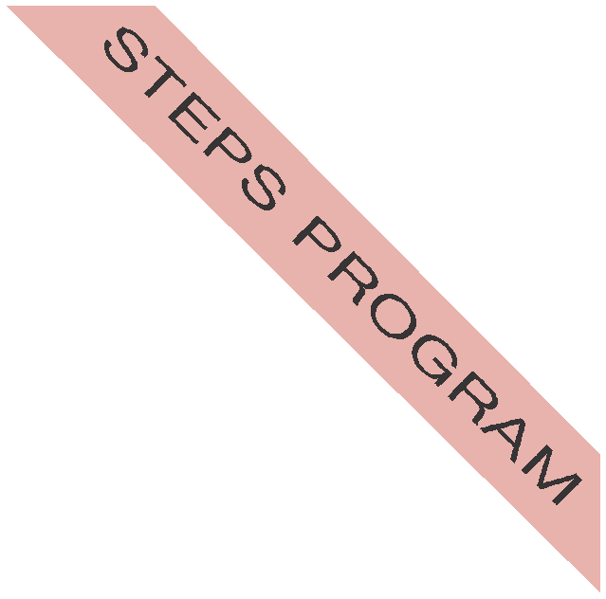

STEPS Program

Skills, Training and Education for Personal
Success
The STEPS is a program that provides a path for students with mild to moderate disabilities to cultivate skills for a successful future. By valuing each student's unique abilities and developing their individual potential, we provide educational enrichment and the skills for meaningful employment. Our students graduate with confidence, self-reliance and the tools to become a vital member of the community.

College and Career Readiness

Support

Austin Community College’s STEPS offers a variety support to help adults achieve their goals. Working together with agencies and schools, we provide comprehensive supports through their entire two years leading towards increased independence and employ-ability.

Choices

Whether a student wants to continue their education or jump into the workforce, STEPS will give them the jumpstart to becoming successful.

Individualized Instruction

Individualized instruction is important to student success through STEPS. During the intake interview students skills and interests are evaluated.

Graduation Plan

Students complete a graduation plan during their intake based on their long-term goals and interests.

Social Skills

Developing appropriate social skills is a central element in all ACC’s STEPS classes. Students learn how to handle stressful situations, interact with coworkers and peers as well as handle the responsibilities of begin an adult.
Program Information

Estimated Tuition
$896.00 per class
May Not Include Books & Fees

Time Commitment Up to 2 years or 6 semesters
Courses + Internship

Contact Information

Program Director Christine Price
cprice12@austincc. edu (512) 223-7856

Steps Program Occupational Skills Award

Students who successfully complete each course of the degree plan and at least 2 elective courses or additional STEPS classes will be awarded the Occupational Skills Award

Take the Next Step!

Contact our program coordinator, Christine Price, to help answer your questions. Visit our webpage to find out additional information on our courses and how to apply.
http://austincc.wix.com/accsteps
Production Date: 10/28/13

